CURRICULUM VITAE

BANSHIDHAR SINGH
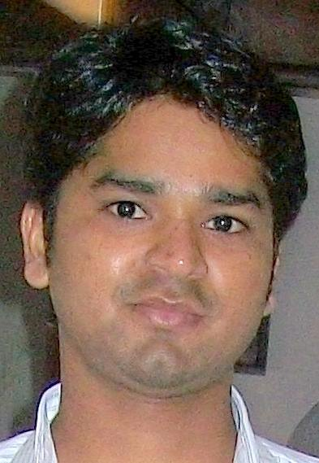

Address : N-1/957, SAMNE GHAT LANKA VARANASI, U.P. Pincode: 221005
Contact No. +91 – 8081197249
E-mail id : banshidharsingh97@gmail.com

Career Objective
To get quality learning exposure and willing to work as a member of team using your organization as platform and my dedication, hard work and innovation as fuel.

Academic Background

 | Board | Name of Institute | Year | Percentage
Bachelor of Pharmacy | G.B.T.U. | Babu Banarasi Das National Institute Of Technology And Management | 2014 | 65%
Intermediate | BIHAR BOARD | S.V.P. COLLEGE | 2008 | 58.7%
High School | BIHAR BOARD | P.D.P HIGH SCHOOL | 2006 | 69.7%

Strengths
I access myself as hardworking, sincere, team player & have leadership skills.

Achievement
- Participated in Utkarsh'13
- Top performance in all india and qualify international tour.
- Top perform in new brand and receive many certificates .
- My performance was more than 110% year to year till date.
- To organize many scientific activities and engage more number of Doctor.

Experience

- 3 year 2 month in sun pharma as a Business executive post from 14 july 2014 to 05 sep 2017
- 6 year in Bayer pharmaceuticals as a Business officer post from 7 sep 2017 to till date

Hobbies
- Play out door game
- travelling
- riding

Computer Proficiency
- Having Skills equipped to deal with M.S. Office and excel for day to day work.

Personal Information

- Father's Name: Mr. Suresh singh
- Date of Birth: 2 january 1990
- Marital status: Married
- Sex: male
- Nationality: Indian
- Languages Known: English, Hindi

Declaration

- I certify that to best of my knowledge and belief, this resume correctly describes me and my qualifications.

- Place: Kanpur
- Date: Banshidhar singh

