CURRICULAM VITAE
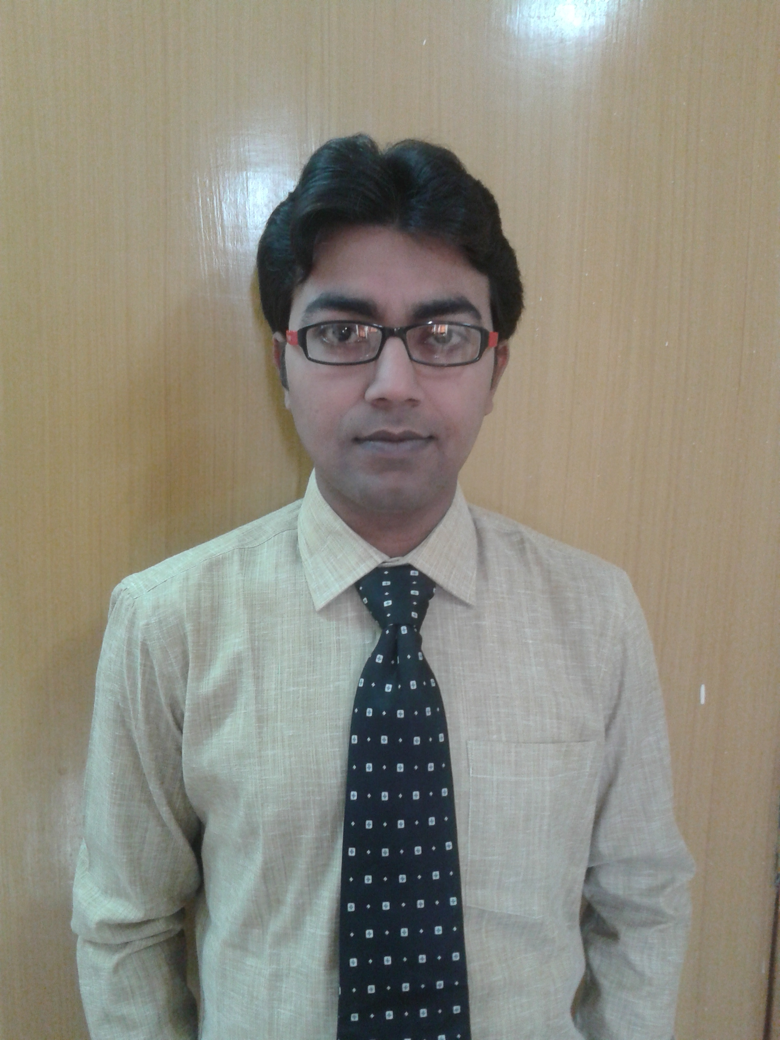
NAME. SANJOY DUTTA
Address: SANJOY DUTTA,GREEN VALLEY APPARTMENT.FLAT NO-1D,2.5 NO GATE,BASU NAGAR,MADHYAMGRAM.KOLKATA-700129
Mobile: 09748981403
E-mail: sanjoy.barasat.dutta@gmail.com

CAREER OBJECTIVE:
To work in a professionally managed atmosphere where all my skills and abilities will be extracted and where with the growth of the organization, I also will be benefited and grow in respect of professional and personal front.
ACADEMIC PROFILE:
Examination Passed | Board/University | Year Of Passing | Percentage Of Marks | Division or Class
B.SC | C.U | 2003 | 41.2 | 2ND
H.S | WBBHSE | 1999 | 67.4 | 1ST
MADHYAMIK | WBBSE | 1997 | 75.4 | 1ST

WORKING EXPERIENCE:
- COMPANY NAME - HETERO HEALTH CARE LTD.
HQ - BARASAT
DESIGNATION - AREA MANAGER
DURATION - APRIL2016 TO MARCH 2022
AREA COVERED – BARASAT, BARACKPORE, BASIRHAT, CONTAI AND MIDNAPORE HEAD QUARTER.
DESIGNATION—REGIONAL MANAGER (2ND LINE)
FROM APRIL-2022 PROMOTED FROM AREA MANAGER TO REGIONAL MANAGER.

ACHIEVEMENTS - RECEIVED BULLET (TWO WHEELER) AND DOMESTIC AND FOREIGN TRIP FOR MY BUDGET ACHIEVEMENT.

- COMPANY - EMCEE PHARMACEUTICALS PVT LTD.
H.Q - BURDWAN
DESIGNATION - AREA SALES MANAGER
DURATION - APRIL 2015 TO APRIL 2016
AREA COVERED - BURDWAN, DURGAPUR, ASANSOL & BANKURA

- COMPANY - MSN LABORATORIES PVT.LTD
H.Q - BARASAT
DESIGNATION - TERRITORY MANAGER
DURATION – JUNE -2008 to APRIL 2015
AREA COVERED - NEWBARACKPUR, MADHYAMGRAM, HABRA,
BONGAON, BASIRHAT, TAKI, ICHAPUR, BARACKPUR
PRODUCT - TAPAL, VITASAFE, FLOXSAFE, TUSAWAY
ACHIEVEMENTS - LAUNCHED MSN IN MY ASSIGNED TERRITORIES AND PARTICIPATED TO GENERATE ANOTHER TWO DIVISIONS MORE.GOT 5TH RANK IN ALL INDIA BASIS IN ATOREM,1ST RANK IN TUSAWAY IN W.B,5TH RANK IN VITASAFE IN W.B

- COMPANY - KHANDELWAL LABORATORIES PVT.LTD
H.Q - KRISHNANAGAR
DESIGNATION - MEDICAL EXECUTIVE
DURATION - NOV-2006 TO JUNE-2008
AREA COVERED - RANAGHAT, SANTIPUR, BETHUA
PALASI, PALSIPARA, KARMPUR, CHAKDAH
PRODUCT - CEFI, RAB-D, DICALCIPLEX, CEFOCLOX, ANAFORTAN
ACHIEVEMENT- LAUNCHED CEFOCLOX & MAINTAINED GROWTH

PERSONAL DETAILS:

Father’s Name : MR.KAMAL KRISHNA DUTTA
Mother’s Name : SMT.UMA DUTTA
Date of Birth : 10-06-1980
Marital Status : MARRIED
Languages known : ENGLISH, HINDI, BENGALI
Hobbies : TRAVELLING, PLAYING

Place: Kolkata
Date: ………………………………………….
Signature

